Cheshire and Merseyside

Health and Care Partnership

Data Sharing Agreement

(Tier Two)

Workstream:
COVID-19 Intelligence

Addendum G - Covid Virtual Ward and Oximetry at Home

Contents

1. Overview 3
2. UK GDPR Legal Basis to Process Patient Data 4
3. Common Law Duty of Confidentiality 4
4. Business Need 4
5. Data Flow 5
6. Access & Governance 5
7. Information Governance 6
8. DAAG: Access Request 6
9. Combined Intelligence for Public Health Action (CIPHA) 7

Addendum G - Covid Virtual Ward and Oximetry at Home

Overview
This Addendum sets out the additional work for the Covid Virtual Ward and Oximetry at Home service.

Pulse oximeters are being provided to patients as part of the NHS response to COVID-19. This service supports people at home who have been diagnosed with coronavirus and are most at risk of becoming seriously unwell. People are provided with a pulse oximeter and supporting information to monitor their oxygen saturation levels at home for up to 14 days, supported by carers and/or family members where appropriate.

COVID virtual wards are for adults being discharged from hospital who have a primary diagnosis of coronavirus but with an improving condition. On discharge to the virtual ward, patients are provided with a pulse oximeter in addition to any other treatment and support they may require.

This Addendum should be read in conjunction with the following documents:

Cheshire and Merseyside Health and Care Partnership:

- Tier Zero Memorandum of Understanding
- Tier One Data Sharing Agreement – Standards

Cheshire and Merseyside Health and Care Partnership:
Workstream: Combined Information for Population Health Action (CIPHA)
COVID-19 Intelligence:

- Data Sharing Agreement (Tier Two) COVID-19 Intelligence
- Data Protection Impact Assessment (DPIA)
- Addendum A - Flu and Pandemic Covid-19 Vaccinations
- Addendum B - Covid-19 Vaccination NIMS
- Addendum C - COVID Transmissions: Mass Testing Vaccinations and Events
- Addendum D - Restoration of Elective Activity
- Addendum E - Pregnancy Register and Covid Vaccinations
- Addendum F – COVID Contact Tracing Programme

UK GDPR Legal Basis to Process Patient Data
For : COVID Cheshire & Merseyside, the Legal Basis under the UK General Data Protection Regulation (GDPR) is as follows:

6 (1) (e) Necessary for the performance of a task carried out in the public interest or in the exercise of official authority vested in the controller

9(2)(h) Necessary for the purposes of preventive or occupational medicine, for the assessment of the working capacity of the employee, medical diagnosis, the provision of health or social care or treatment or the management of health or social care systems and services on the basis of domestic law or pursuant to contract with a health professional and subject to the conditions and safeguards referred to in paragraph 3.

9(2)(i) Necessary for reasons of public interest in the area of public health, such as protecting against serious cross border threats to health or ensuring high standards of quality and safety of healthcare and of medicinal products or medical devices, on the basis of domestic law which provides for suitable and specific measures to safeguard the rights and freedoms of the data subject, in particular professional secrecy.

Common Law Duty of Confidentiality
For COVID Cheshire & Merseyside - the Common Law Duty of Confidentiality is set aside by the COPI Notice.

Business Need
If a patient is diagnosed with covid then additional monitoring can be offered to help improve patient experience and enable proactive intervention. The portal that provides that list of eligible patients will only provide the contact details of the patients without their corresponding health records/ clinical cohort. This means eligible patient prioritisation across covid support services cannot take place prior to offering the service.

By ingesting the eligible patient list from Docobo (Telehealth) into CIPHA, it is possible to match the patients with their care record. This linkage of patient information to the patient’s primary care record will enable the patients’ clinical cohort (selection criteria satisfied) to be shared in advance of any patient contact.

This will enable much richer and more informed conversations with patients, as well as more effective prioritisation across covid support services. Implementing this process via CIPHA will also enable business intelligence on eligible patients and help with capacity and demand forecasts across associated services.

Data Flow
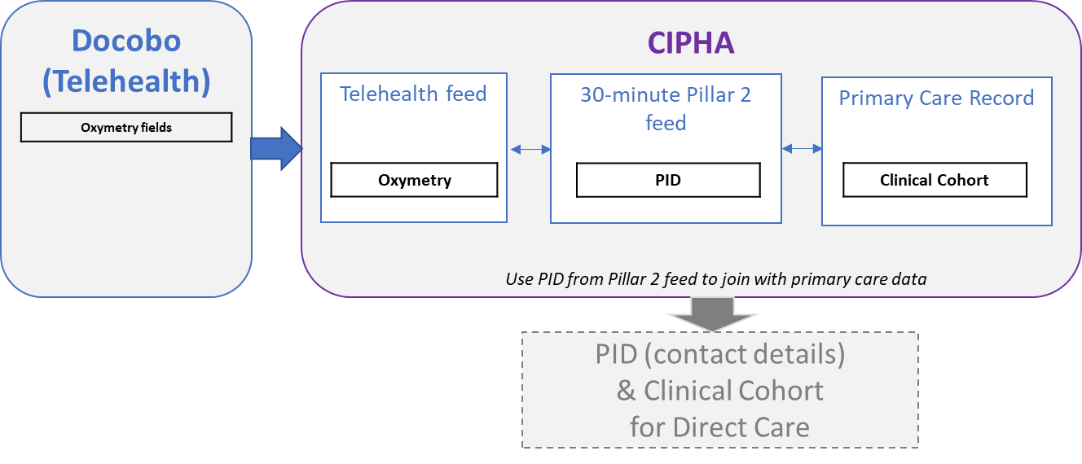

Data sets in scope,
- Oxymetry data – to identify patients in scope
- Covid Test Results – to validate patient in scope
- Primary Care record – to determine the clinical cohort for each patient (why they are eligible)

Access & Governance
Mersey Care provide the Telehealth Team service, where the clinicians in the team already have access to patient level detail for the patients in scope for Telehealth services. The telehealth data will flow into CIPHA in an identifiable form so CIPHA can link the Telehealth patient with their primary care record, thus giving the clinicians richer and more granular data for their patients to help cohort the patients and manage the service.

No new access to Patient Identifiable Data (PID) will be provided than currently exists. The PID is for contact purposes only and will be shared with the Telehealth administrator and the clinicians who have a direct care relationship with the patient. Once the Telehealth staff have on-boarded the patient, their contact details and clinical cohort (indicating why they have been identified as eligible for the service) will be shared with the clinician who will monitor the patient. Role Based Access Control (RBAC) is utilised in CIPHA to ensure that only relevant access is provided.

The SOP embedded below further explains the clinical criteria for this service:

Information Governance
Patients for virtual ward and oximetry at home are identified via the following three data flows:

- Docobo (Telehealth) feed showing current telehealth patients
- 30 minute testing feed identifying covid patients (from DHSC Pillar 2)
- Primary Care Record data

The proposal is to link these feeds providing identifiable patient lists to the patients primary care record in order that patients can be contacted.

B and C already flow into CIPHA and have Information Governance coverage from two existing Data Sharing Agreements (DSAs) below:

- DHSC DSA
- HCP C&M Data Sharing Agreement (Tier Two) COVID-19 Intelligence

This Addendum G, to the HCP C&M Data Sharing Agreement (Tier Two) COVID-19 Intelligence, includes the Docobo/tele health dataset as a dataset that flows into CIPHA for linkage. Mersey Care are the data controller, so there are no changes to data controllers or data processors, just a new dataset, and therefore addendum for information rather than for signature.

DAAG: Access Request
In support of this data flow, the local DAAG: Access Request form - Covid Virtual Ward and Oximetry at Home is embedded below:

Combined Intelligence for Public Health Action (CIPHA)

For further information please see the following websites:

Cheshire and Merseyside Health and Care Partnership
https://www.cheshireandmerseysidepartnership.co.uk/about-us/

Combined Information for Population Health Action (CIPHA)
www.cipha.nhs.uk

CIPHA Information Governance
CIPHA - Information Governance (IG)

Share2Care
www.share2care.nhs.uk

